# Looking Inside the Firewall Internal Database

1. First, enable the ‘dbfw_report’ user in SQL Plus on your Firewall box, as follows (The documentation for this is at [http://download.oracle.com/docs/cd/E20465_01/doc/doc.50/e18695/standalone.htm#CBBGHGHH](http://download.oracle.com/docs/cd/E20465_01/doc/doc.50/e18695/standalone.htm%23CBBGHGHH):
   1. <Alt>F2 brings you into Linux
   2. Log in as your ‘support’ user, then su to root:
      * su -
   3. Change to the oracle user.
      * su - oracle
   4. Set the following environment variables:
      * export ORACLE_HOME=/var/lib/oracle/dbfw
      * export ORACLE_SID=dbfwdb
      * export PATH=$PATH:$ORACLE_HOME/bin/
   5. Log in to the database on this server using SQL*Plus.
      * sqlplus sys/as sysdba
      * Enter password: <password>
   6. Enable the dbfw_report account and grant this user a password.
      * ALTER USER dbfw_report ACCOUNT UNLOCK IDENTIFIED BY< password>;
   7. Exit SQL*Plus.
2. Be sure you have Port 1521 open on the Firewall Server. To do this, on your Windows box, log into the DBFW console.
   1. Pick System, Settings and then click on ‘Change’:

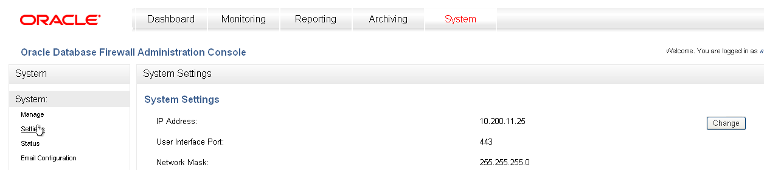

* 1. Scroll down and enter the word ‘all’ in both the Secure Log Access and Traffic Log Access fields:

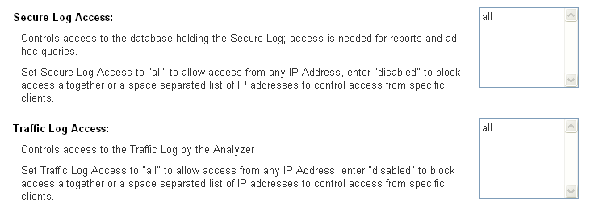

* 1. Hit ‘Apply’ (Bottom Right) and wait for the changes to take effect.

1. Now, on your Windows box, open SQL Developer
2. Create a new connection to the Database called ‘dbfw’:

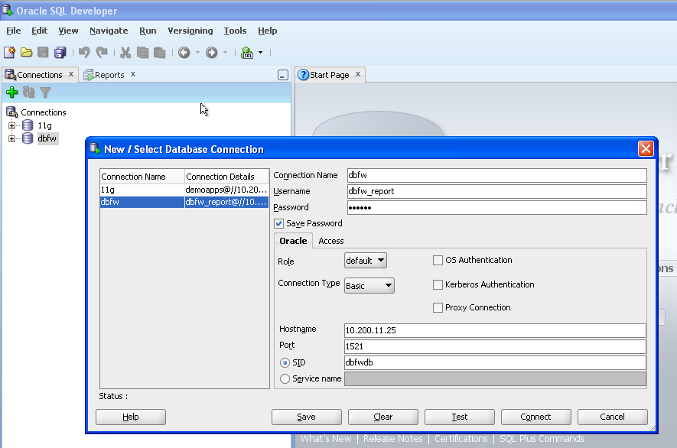

1. Open the connection, and scroll down to ‘Other Users’, at the bottom.
2. The schema for all the relevant tables is SECURELOG:

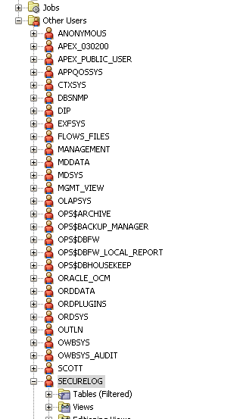

1. Let’s look at some interesting Tables
   1. SUMMARY_CLUSTERS – See the Clusters you worked with in Analyzer
   2. SUMMARY_RECORDS – the key to the data in these columns is the DICTIONARY Table
   3. For full documentation of the Tables here, see:
   4. [http://download.oracle.com/docs/cd/E20465_01/doc/doc.50/e18695/db_schema.htm#sthref257](http://download.oracle.com/docs/cd/E20465_01/doc/doc.50/e18695/db_schema.htm%23sthref257)
   5. Note: There is information in this section that is outdated and confusing. We have filed a bug about this, but the descriptions of the various tables are useful.
2. Trying to view the data in the SQL Developer Data Tab for the DICTIONARY Table yields an error.
   1. To get around this, open a new SQL Worksheet as follows:

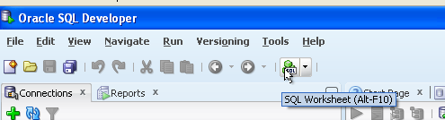

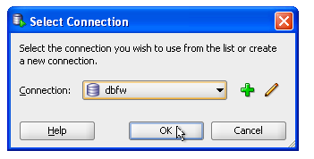

* 1. Type ‘select * from securelog.dictionary’ and hit the green (Run Statement) arrow:

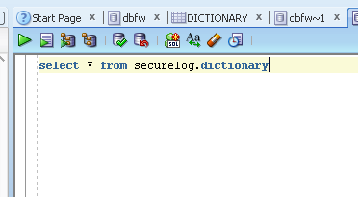

* 1. Scroll through the results in the Query Results window. This will help you interpret many of the values you are seeing in other tables.

